MES Wadia College of Engineering Pune-01
Department of Computer Engineering
Name of Student: | Class:
Semester/Year: | Roll No:
Date of Performance: | Date of Submission:
Examined By: | Experiment No: Part A-08

PART: A) ASSIGNMENT NO: 08
Title: Data Visualization-I
1. Use the inbuilt dataset 'titanic'. The dataset contains 891 rows and contains information about the passengers who boarded the unfortunate Titanic ship. Use the Seaborn library to see if we can find any patterns in the data.
2. Write a code to check how the price of the ticket (column name: 'fare') for each passenger is distributed by plotting a histogram.

OBJECTIVES:
- Students should be able to perform the data Visualization operation using Python on any open source dataset.

PREREQUISITE:
- Basic of Python Programming.
- Seaborn Library, Concept of Data Visualization.

APPRATUS:
- Programming Language: Python.

CONCLUSION:

QUESTIONS:
- List out different types of plot to find patterns of data
- Explain when you will use distribution plots and when you will use categorical plots.
- Write the conclusion from the following swarm plot (consider titanic dataset)
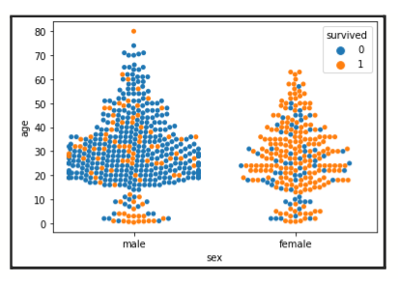
- Which parameter is used to add another categorical variable to the violin plot, Explain with syntax and example?

